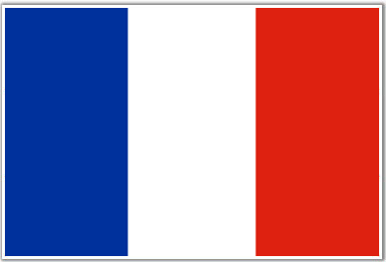  
  
France

7 x 2

10 x 2

5 x 2

12 x 2

1 x 5

9 x 5

4 x 5

4 x 2

12 x 5

5 x 5

3 x 2

11 x 5

3 x 5

9 x 2

8 x 5

1 x 2

10 x 5

7 x 5

6 x 5

11 x 2

8 x 2

2 x 2

2 x 5

6 x 2

9 x 2

8 x 5

  
France

2 x 5

11 x 2

10 x 2

12 x 5

5 x 5

6 x 5

4 x 2

8 x 2

4 x 5

5 x 2

9 x 5

2 x 2

1 x 5

3 x 2

1 x 2

7 x 2

3 x 5

6 x 2

10 x 5

7 x 5

11 x 5

12 x 2