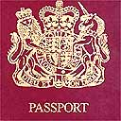

|  |  |
| --- | --- |
| AUSTRALIA | CHINA |
| CANADA | USA |
| MEXICO | BRAZIL |
| ENTRY BACK INTO THE UK | |
| EGYPT |  |
| KENYA |  |
| SOUTH AFRICA |  |

|  |  |
| --- | --- |
| UNITED KINGDOM | FRANCE |
| SPAIN | ITALY |
| EGYPT | KENYA |
| SOUTH AFRICA | INDIA |
| EGYPT |  |
| KENYA |  |
| SOUTH AFRICA |  |