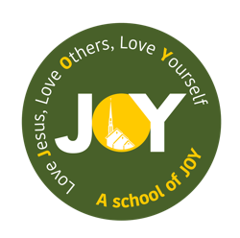
St Josephs and The Cathedral School of St Mary
Foundation – Autumn 1 2025
All about me

Foundation | Week 1  04.09.25 | Week 2  08.09.25 | Week 3  15.09.25 | Week 4  22.09.25 | Week 5  29.09.25 | Week 6  06.10.25 | Week 7  13.10.25
Key Dates/Info | Staggered start  Th 8.45-11.15 + 1-3.30  F 8.45 – 11.15 + 1-3.30 | Staggered start  M 8.45-12.30 +  130-3.30  T 8.45-12.30 +  130-3.30  W All chn all day  09.09.25 National Teddy bear day | Parents / carers to send in family photos and baby / toddler photos for next week  Start RWI + Pathways | 23.09.25 International Day of Sign language  26.09.25 International Day of Language+s | 29.09.25 World Heart Day  Plant spring flowering bulbs in the school grounds – “Foundation Garden” | 06.10.25 World Habitat Day  10.10.25 World Mental Health Day  Black history month (01/10/25 – 31/10/25) | 16.10.15 World Food Day  Making and decorating fairy cakes to take home
Educational Visits/  Experiences | Settling / Baseline | Settling / Baseline | Settling / Baseline | Settling / Baseline  Visit to the Cathedral (with Canon to talk about Mass and Baptism) | Settling / Baseline | Settling / Baseline  Local area walk | Settling / Baseline
Weekly theme | Starting school | Who am I? | My body | Who is in my family? | Belonging | Who and what is in my community | People who help us
Vocabulary | School, home, sad, happy, worried, scared, excited, names of children, adults and areas | Self-portrait, eyes, nose, mouth, ears, features, hair | Body, height, skeleton, skin, similarities, differences | Family, mum, dad, sister, brother, auntie, uncle, grandma/grandpa ,cousin (also special words the children might use for these people), member | Belong, club, group, teamwork, community, different | Community, local area, Church, library, shop | Doctor, nurse, firefighter, police officer, ambulance, paramedic, dentist, carers, teachers
Key Text | The Colour Monster and Colour Monster Goes to School by Anna Llenas  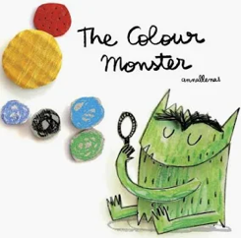  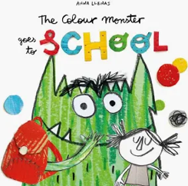 | Super Duper You by Sophie Henn  Can I Build Another Me By Shinsuke Yoshitake  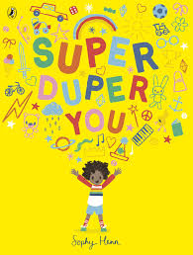  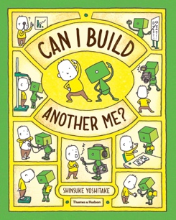 | Usborne ‘See inside your body’.  Usborne ‘Look inside your body’  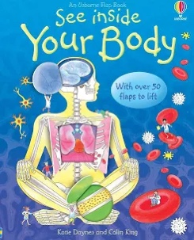  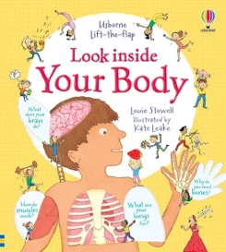 | Families, Families, Families! By Anne and Max Long  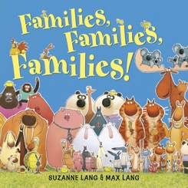  What type of family are we? Lizzy Seaton  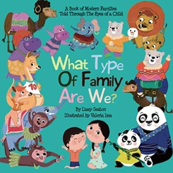 | The Rainbow Fish - Marcus Pfister  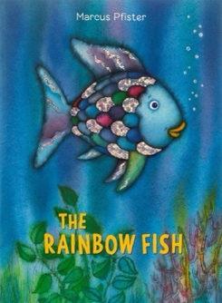 | Last stop on Market Street by Matt De La Pena  The Girl who planted trees by Caryl Hart and Anita Suvorova  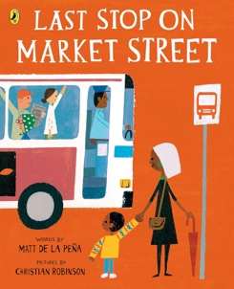  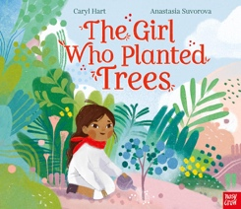 | Real Superheroes - A celebration of key workers by Julia Seal  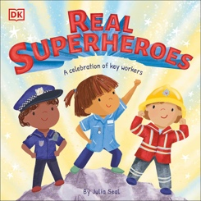
Literacy  Peace at last – Jill Murphy (Pathways)  WK 3 Start  15 sessions taught 3x per week  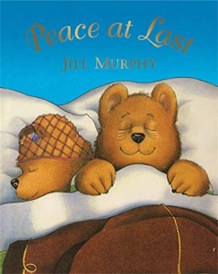 | Baseline  Understand the key concepts about print.  Talk about the stories they have learnt using new vocabulary.  Begin writing and identifying their first name with and then without a reference.  Answer ‘what’ ‘who’ and ‘when’ questions related to a story.  Read individual letters by saying the sounds for them. | Baseline  Understand the key concepts about print.  Talk about the stories they have learnt using new vocabulary.  Begin writing and identifying their first name with and then without a reference.  Answer ‘what’ ‘who’ and ‘when’ questions related to a story.  Read individual letters by saying the sounds for them. | Baseline  Understand the key concepts about print  Talk about the stories they have learnt using new vocabulary.  Continue writing and identifying their first name with and then without a reference.  Answer ‘what’ ‘who’ and ‘when’ questions related to a story.  Write some letters.  Read individual letters by saying the sounds for them.  Begin to blend sounds into words so that I can read some short words. | Baseline  Understand the key concepts about print  Talk about the stories they have learnt using new vocabulary.  Continue writing and identifying their first name with and then without a reference.  Answer ‘what’ ‘who’ and ‘when’ questions related to a story.  Write some letters.  Read individual letters by saying the sounds for them.  Begin to blend sounds into words so that I can read some short words. | Baseline  Understand the key concepts about print  Continue writing and identifying their first name with and then without a reference.  Answer ‘what’ ‘who’ and ‘when’ questions related to a story.  Read individual letters by saying the sounds for them.  Begin to blend sounds into words so that I can read some short words.  Write some letters.  To begin to write initial sounds as captions. To use some of their print and letter knowledge to write for a purpose. | Baseline  Understand the key concepts about print  Continue writing and identifying their first name with and then without a reference.  Answer ‘what’ ‘who’ and ‘when’ questions related to a story.  Read individual letters by saying the sounds for them.  Begin to blend sounds into words so that I can read some short words.  Write some letters.  To begin to write initial sounds as captions. To use some of their print and letter knowledge to write for a purpose. | Baseline  Understand the key concepts about print  Continue writing and identifying their first name with and then without a reference.  Answer ‘what’ ‘who’ and ‘when’ questions related to a story.  Read individual letters by saying the sounds for them.  Begin to blend sounds into words so that I can read some short words.  Write some letters.  To begin to write initial sounds as captions. To use some of their print and letter knowledge to write for a purpose.
Maths | Baseline  Number rhymes and counting songs continuing from nursery | Baseline  MN WK1: Subitising | Baseline  MN WK2: Counting, cardinality and ordinality | Baseline  MN WK3:  Composition | Baseline  MN WK4: Subitising | Baseline  MN WK5: Comparison | Baseline  MN WK6: Counting, ordinality and cardinality
RE | Introducing the 3 school prayers  Morning, grace and afternoon | Creation and Covenant:  I know that God made me. | Creation and Covenant:  I know God loves me and I am part of a family. | Creation and Covenant:  I know we should look after ourselves and others | Creation and Covenant:  I know that God made our world. | Creation and Covenant:  I know we should look after God’s world. | Creation and Covenant:  I know that we are all invited to be part of God’s family
PSED/  Gospel Values | Belonging/  Relationships  Introducing ‘ready, respectful and safe’  Behaviour expectations  Silent signals  123 transition
Communication & Language | Children will be exposed to new vocabulary and will start to use these in context correctly through development of oracy skills. (Continued throughout Autumn term)  Children will answer simple questions to show their understanding.  Children will listen and take turns in speaking.  Children will have a broad experience of listening to stories and being able to explain what is happening.  Explore and talk about feelings specifically using The Colour Monster book. | Children to share something special about them. Is it the same as anyone else?  What are the similarities and differences between us as a class. Children will listen and take turns in speaking.  Children will answer simple questions to show their understanding. | Head, shoulders, knees and toes  Simon Says..  Naming parts of the body. Children will listen and take turns in speaking.  Explore senses  Children will answer simple questions to show their understanding. | Choose a member of their family to talk about. Questioning. Children will listen and take turns in speaking.  Children will answer simple questions to show their understanding. | What does it mean to belong? What groups do we belong to?  Children to share groups they belong to eg church, etc. Children will listen and take turns in speaking.  Children will be encouraged to speak in longer sentences with the modelled use of sentence stems. | What makes the community. What can you see when you walk around our community.  Why should we look after our community and those in it? Children will listen and take turns in speaking.  Children will be encouraged to speak in longer sentences with the modelled use of sentence stems. | Invite a police/firefighter or paramedic in the talk to the children about how they help the community. Children will listen and take turns in speaking.  Children will be encouraged to speak in longer sentences with the modelled use of sentence stems.
Understanding the World | Starting school - Explore the way they got to school and what they passed on the way | Discuss what ‘being me’ means.  Complete the ‘I am…’ poster | Naming parts of the body  Exploring our senses | Look at family timelines (baby to old person) - exploring and then creating their own from baby to starting school | Discuss what other groups we belong to. Discussion around school of joy badge - belonging to the school family | Make a map of the local area, ensuring that you identify the important buildings to the community | Think about a time they were poorly or a family member was - who looked after them?
Expressive Arts and Design | Explore colours using the colour monster - mixing up emotions (colours) and seeing what they get | Painting self-portraits using mirrors to point out key features | Use natural materials to create and decorate a face | Recreate a family photo using media of their choice e.g. crayons, pens, paint.  How easy was it to recreate the photo? | Design a scale to create a large rainbow fish display | Black history month focus  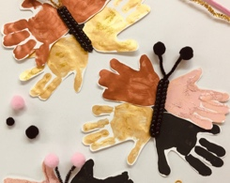  Make butterfly’s using handprints of different skin colours. | Look at some images of fingerprints. Pupils are to look at their own fingerprints using magnifying glasses.  Make a fingerprint art card and give it to someone who helps us.
Computing / Technology |  | Children to use ipad to take pictures of themselves | Recognise and search a range of technology used in the home. | Explore how families communicate with one another and keep in touch, especially with those members they don’t live with eg email, text, etc. | Create a video performance of ‘All join in’ by Quentin Blake. | Talk to the pupils about technology that has been  developed to help people e.g.  dictation programs. | Using pictures on the local area walk and use them to make a map collage.
Physical Development | Fine and Gross motor skills  Pencil grip in CP  Determining which hand they make marks with and show some control. | Fine and Gross motor skills  PE Passport - Fundamental Movement Skills  ‘I can run skillfully and negotiate space’ | Fine and Gross motor skills  PE Passport - Fundamental Movement Skills  ‘I can pick up, carry and put down with care’ | Fine and Gross motor skills  PE Passport - Fundamental Movement Skills  ‘I can show increasing control over an object’ | Fine and Gross motor skills  PE Passport - Fundamental Movement Skills  ‘I can balance and move through an obstacle course’ | Fine and Gross motor skills  PE Passport - Fundamental Movement Skills  ‘I can be excited about and confident in my role in a team’’ | Fine and Gross motor skills  PE Passport - Fundamental Movement Skills  ‘I an thread objects and play games fairly’

