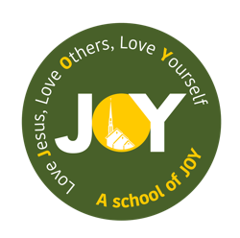
St Josephs and The Cathedral School of St Mary
Foundation – Autumn 2 2025
Let’s celebrate.

Foundation | Week 1  04.11.25 | Week 2  10.11.25 | Week 3  17.11.25 | Week 4  24.11.25 | Week 5  01.12.25 | Week 6  08.12.25 | Week 7  15.12.25
Key Dates/Info | Diwali 18th -24th October (20th October 2025)  Bonfire Night 05.11.25  Local area walk | Start sending home Travelling Crib  Anti-Bullying Week 10.11.25 – 14.11.25  Remembrance Day 11.11.25  13.11.25 World Kindness Day | 18.11.25 – World Princess Day | Advent  30.11.25 – 24.12.25 |  | Nativity Performance and Christmas Cards  Advent Afternoon - Nativity with linked activities, families invited.
Educational Visits/  Experiences |  |  | Visit from the library | Bear hunt around grounds of school |  | Letter and ‘visit’ from an Elf | Making gingerbread to take home
Weekly theme | How do people celebrate? | How can you be a good friend? | What does a witch need for her spell? | What’s it like outside? | What can I see in the dark? | How do people celebrate Christmas? | How do people celebrate Christmas?
Vocabulary | Diwali, Hindu, Rama, Sita, celebrate | Friendship, share, forgiveness, kindness, bullying | Rhyme, spell, witch, cauldron, bog | Autumn, leaves, squirrels, pumpkins | Shadows, light, dark, torch | Elf, door, Father Christmas, RE vocab | Mary, Joseph, Jesus, Bethlehem, donkey, wisemen, angels
Key Text | The story of Rama and Sita  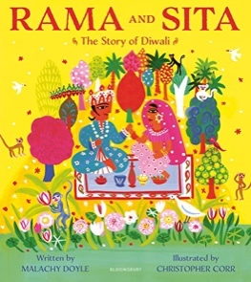 | The Longest Wait by  Alison Brewis  Meesha makes friends by Tom Percival  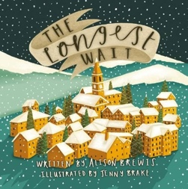  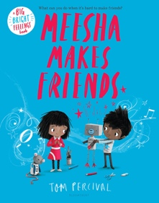 | Room on the broom by Julia Donaldson  Meg and Mog by Helen Nicoll and Jan Pienkowski  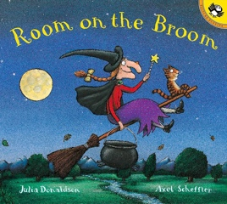  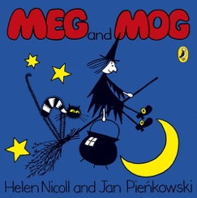 | We’re Going on a Bear Hunt by Michael Rosen  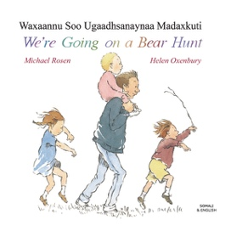 | Owl Babies by Martin Waddell  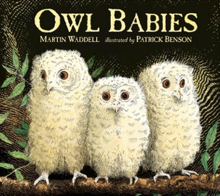 | Joy to the World!-Christmas around the Globe by Kate DePalma  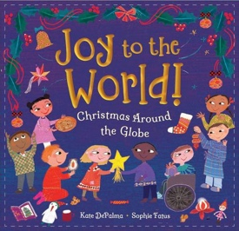 | Jesus Christmas Party by Nicholas Allen  Stick man by Julia Donaldson  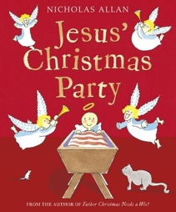  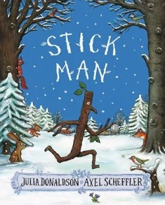
Literacy  Festivals by Jane Bingham (Pathways Text)  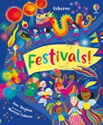  Experience both fiction and non-fiction texts, understanding the key differences.  Introduce and understand new vocabulary. | I know the individual letters taught so far.  I can orally blend and segment simple words.  I know how to read simple words with sounds that I am familiar with.  I know how to write simple words using sounds that I am familiar with. | I know the individual letters taught so far.  I can orally blend and segment simple words.  I know how to read simple words with sounds that I am familiar with.  I know how to write simple words using sounds that I am familiar with.  To use initial sounds as captions.  To use some letter knowledge when writing in my play. | I know how to spot and suggest rhymes.  I know the individual letters taught so far.  I can orally blend and segment simple words.  I know how to read simple words with sounds that I am familiar with.  I know how to write simple words using sounds that I am familiar with. | I know the individual letters taught so far.  I can orally blend and segment simple words.  I know how to read simple words with sounds that I am familiar with.  I know how to write simple words using sounds that I am familiar with. | I know the individual letters taught so far.  I can orally blend and segment simple words.  I know how to read simple words with sounds that I am familiar with.  I know how to write simple words using sounds that I am familiar with. | I know the individual letters taught so far.  I can orally blend and segment simple words.  I know how to read simple words with sounds that I am familiar with.  I know how to write simple words using sounds that I am familiar with. | I know the individual letters taught so far.  I can orally blend and segment simple words.  I know how to read simple words with sounds that I am familiar with.  I know how to write simple words using sounds that I am familiar with.
Maths | MN WK7: Comparison | MN WK8: Composition | MN WK9: Composition | MN WK10: Counting, ordinality and cardinality | MN WK11: Subitising | PM Unit 6- Space  Select, rotate and manipulate shapes in order to develop spatial reasoning skills. | MN WK 12: Counting, ordinality and cardinality
RE | Prophecy and Promise  I know that Mary was chosen by God to be Jesus’ mother. | Prophecy and Promise  I know that Mary and Joseph travelled to Bethlehem. | Prophecy and Promise  I know that Jesus was born in a stable and laid in a manger. | Prophecy and Promise  I know that Shepherds visited Jesus in the stable. | Prophecy and Promise  I know that Advent is a time to get ready for Christmas. | Prophecy and Promise  I know that Jesus came for the whole world. | Prophecy and Promise  Celebration of learning.
PSED/
Gospel Values
Communication & Language  They will use and answer simple questions about ‘who’, ‘what’ and ‘where’ to show their understanding.  Continuing from last term determining which hand they make marks with and show some control. | Learn new vocabulary.  Speak in sentences.  Using non-fiction books. | I know how to talk to my friends and listen to them carefully when they respond. | I know how to listen to longer stories and can talk about what has happened in the story.  Descriptive language. Talking in full sentences.  Joining in with refrains of Room on the Broom. | Oracy skills are being developed by speaking in longer sentences and using connectives to join ideas. | I know about some non fiction books and can use words that I have learnt from these books to help me to talk about light and dark. | I know how to share my ideas clearly. | I know how to retell a story using words I have learnt from that story. I know how to describe events in detail.

Understanding the World | I know about some people from the past. (Guy Fawkes)  I know that people celebrate differently and can talk about some celebrations. | I know how historical events have shaped the world today. | Make observations about plants and animals - seed planting. | I know how to use a simple map to find things out.  Talk about features of their immediate environment and how it might differ from other environments. | I know how to explore the world around me and talk about what I can see, hear, feel etc. | I know that people celebrate differently and can talk about some celebrations. | I Know about the changing seasons- Autumn to Winter.
Expressive Arts and Design  Performing-Nativity songs  I know entire songs and can remember these.  I can sing in a group increasingly matching the pitch and following the melody. | I know what a diwa is.  I know how to follow instructions to make a diwa and then choose resources to make my diwa look how I have planned it to. | Making friendship gifts for other children in the class  Poppy art for Remembrance Day | I know how to play cooperatively to develop and act out a narrative. | Colour Mixing-linked to Autumn leaves  Using leaves to create art | Make an owl baby using mixed materials (white feathers, pom poms, cotton wool) | Recreate ‘Squares with concentric circles’ by Kandinsky-linked to shape learning.  I know how to follow instructions to make something then add my own ideas to make it even better.  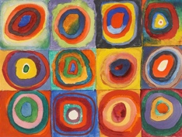 | Christmas crafts + cards
Computing / Technology | Computer science:  Children have a go at writing CVC words on a keyboard, locating relevant keys and seeing the correlation of pressing and appearing | Computer science: mouse pad control. Children use the mouse to navigate specific areas on chrome books | Digital literacy: play a game on the IWB | Safe use: What do the children want to know? Use the internet to learn new information by giving it a specific instruction | Computer science: Use of everyday life technology and understanding that they often use computers.  Maddie’s, ‘Do you Know’ BBC – Fridge, Hoover, TV, Washing machine | Computer science: To understand that photos and text can be printed and reproduced using the printer/photocopier and to use this in their own learning. Print photos of Kadinsky’s art for the children to replicate | Safe use: Know and talk about the different factors that support their overall health and wellbeing, including sensible amounts of ‘screen time’.
Physical Development | Fine and Gross motor skills  PE Passport: Dance - Nursery Rhyme  I know how to hold a pencil correctly.  I am beginning to know how to form letters correctly.  I know how to use scissors.  I know how to control a ball and other equipment. | I know how to hold a pencil correctly.  I am beginning to know how to form letters correctly.  I know how to use scissors.  I know how to control a ball and other equipment. | I know how to hold a pencil correctly.  I am beginning to know how to form letters correctly.  I know how to use scissors.  I know how to control a ball and other equipment. | I know how to hold a pencil correctly.  I am beginning to know how to form letters correctly.  I know how to use scissors.  I know how to control a ball and other equipment. | I know how to hold a pencil correctly.  I am beginning to know how to form letters correctly.  I know how to use scissors.  I know how to control a ball and other equipment. | I know how to hold a pencil correctly.  I am beginning to know how to form letters correctly.  I know how to use scissors.  I know how to control a ball and other equipment. | I know how to hold a pencil correctly.  I am beginning to know how to form letters correctly.  I know how to use scissors.  I know how to control a ball and other equipment.

Computing is not assessed as part of the Development Matters Framework. Although there is not an outcome, the children are exposed to Computing throughout the Early Years beginning with understanding the function of a switch for example the use of a torch or camera. This progresses further by the children exploring how a Bee bot can move and understanding how to code the Bee bot on a journey. (Computer Science.) The children are exposed to technology through the use of the interactive whiteboards and age-appropriate programmes when using the iPads, such as making marks and changing colours, progressing to creating an illustration. (Digital Literacy) The children are taught the importance of e-safety, understanding basic warning signs and to always seek an adult when they are unsure. (Safe Use)

